Final Changes
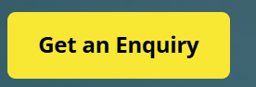
- Can this be changed to “Make an Enquiry” on the front page, top right corner. Also at the bottom of pages.

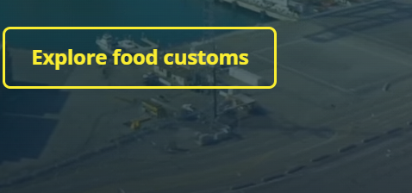
- Could you get rid of this on the front page, only have “Make an Enquiry” and get rid of

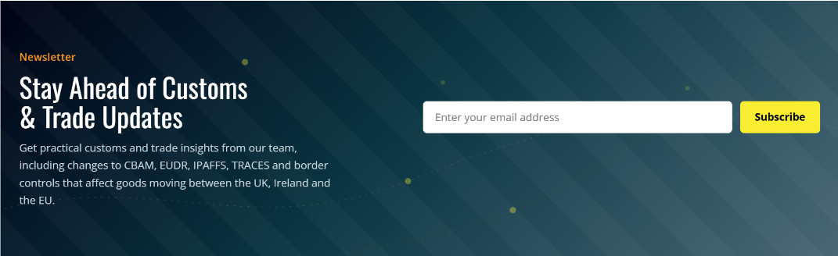
- Could this be removed, as we don’t have a newsletter.
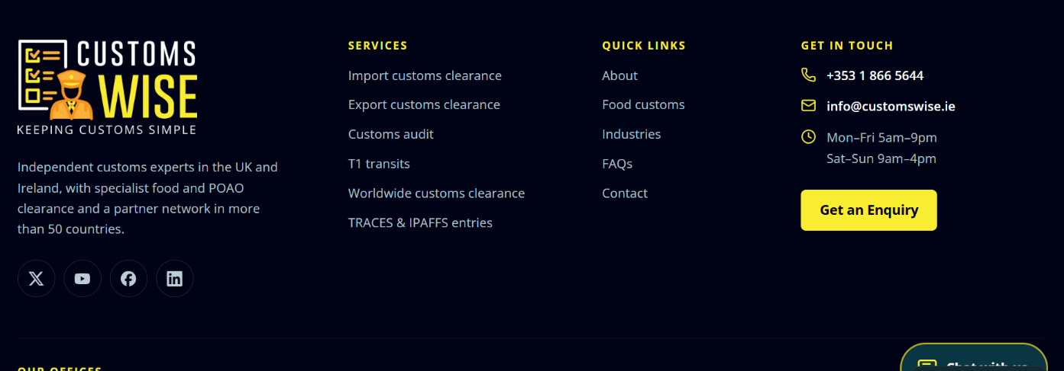
- This sentence on the left doesn’t make sense. Could it be changed to “Independent Customs experts in the UK and Ireland, providing the most efficient solutions to save you time and money. With access to a global network of customs brokers providing support worldwide.”
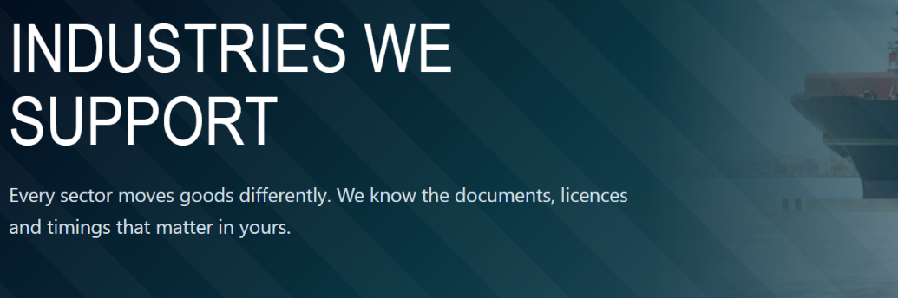
- Could you change this to “Specialist industries we support” then underneath “Clearing some complex goods often requires in-depth technical knowledge. We have 75 employees across five countries, with expertise across a wide range of industries.”

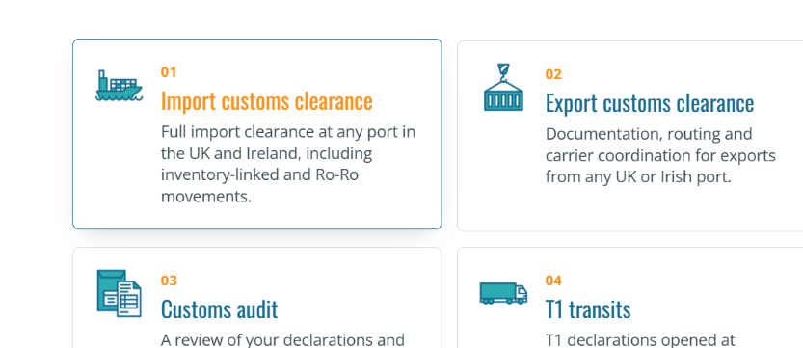
- Could the numbers in orange on services be removed. 01/02 etc Also underneath it says service 01 service 02 etc could this also be removed.

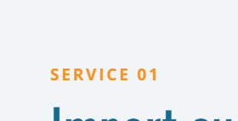

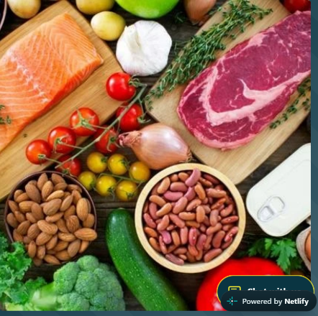
- This picture is a little bit blurry on the website. Would you like me to find a better quality picture, or can I download it again in a different format ? I bought the pictures on

- With the blogs, there is no option to click on a blog section at the top. Is it not possible to have a blog section next to customs insights ? If this is a long fix, then we can leave it for now and up-date it later in the week.

- Also, when you click on the phone button, could it take you to contact details Rather than open a page to make a call, just as most people will be using their laptops so won’t connect.

